**ENEL 476 Assignment #1 – Time-varying Electromagnetic fields**

**(Ch. 9 – 8th ed or Ch. 10 – 7th ed)**

**Assignment will not be marked or handed in, however solutions will be posted on Blackboard on Jan 27**

1. A rectangular loop is placed in a time-varying magnetic flux density described by:

Wb/m2

The loop contains 2 resistors (see figure) and has an area of 10 cm2.

Find the expressions for the voltages across the 2 resistors, V1 and V2.

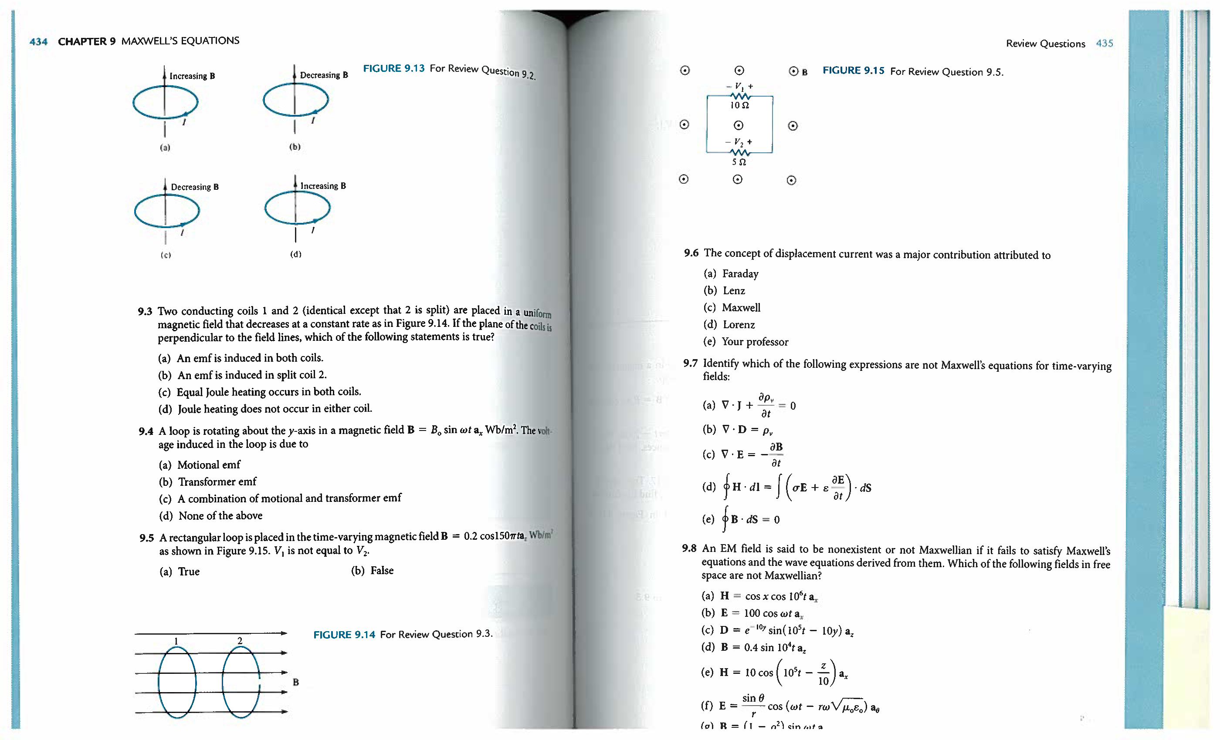

1. Two conducting bars slide over two stationary rails, as shown in the figure below. If **B**=0.2**az**, then find the induced EMF in the loop.

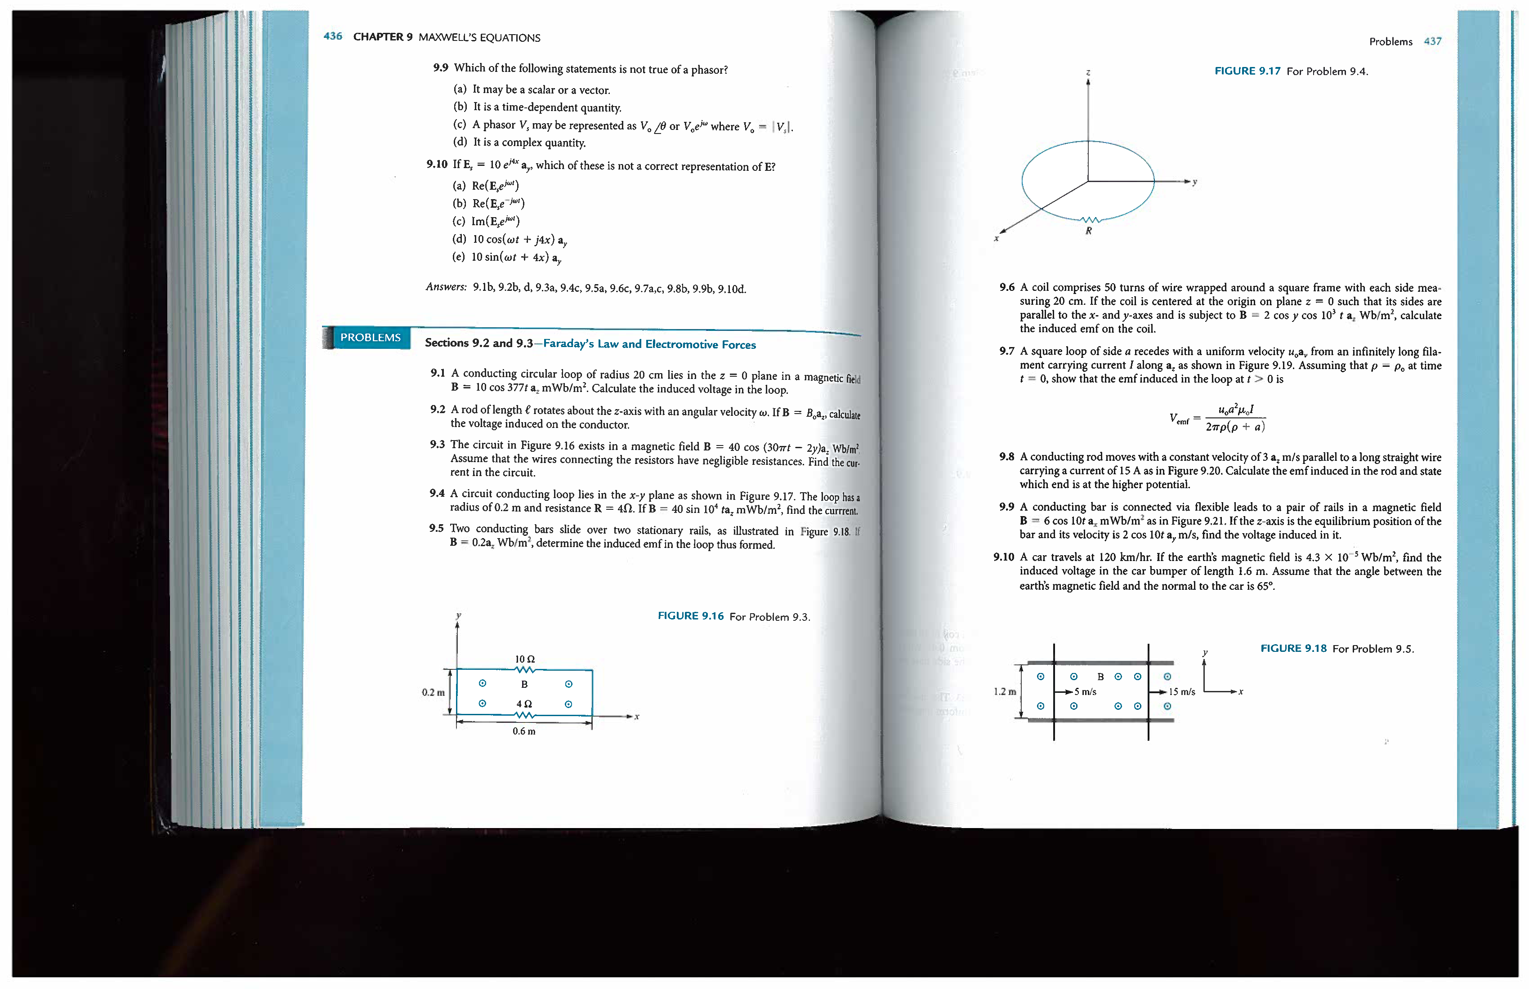

1. A capacitor is filled with Teflon having relative permittivity r=2.4. The capacitor is connected to a generator that operates at 10 MHz and supplies 10 V. If the parallel plate capacitor has plate area of 1.5 cm2 and separation between the plates of 0.1 mm, find the maximum values of displacement current density and total displacement current.
2. A parallel-plate capacitor of plate area S is connected to a time-harmonic generator operating at a (low) frequency f. The capacitor is filled with a two-layer perfect dielectric. Layer 1 has thickness of d1 and permittivity 1. Layer 2 has thickness d2 and permittivity 2. The peak value of the conduction current intensity in the capacitor terminals is Io. The effects of fringing may be neglected.
   1. Find the maximum amplitude of the displacement current in each layer.
   2. Find the maximum amplitude of the electric field intensity in each layer.
   3. Find the maximum amplitude of the voltage across the capacitor.
3. In a certain region for which =0, =2o and =10o, the displacement current density is given by:

mAm 2

1. Find expressions for **D** and **H**.
2. Determine .
3. In free space,

V/m

Find **H**.